**Jenkins User Management**

* Authentication Methods
  + Delegate to Servlet container
  + Jenkins own user database
  + LDAP
  + Unix user/group database
* Creating users inside jenkins
* Configuring authorization
  + Logged in users can do anything
  + Matrix Security
  + Project Based Security
  + Role based Security (Plugin needs to be installed)

**Global Tool Configuration**

* Jenkins offers Global tool configurations and also provides some installers for JDK, maven, gradle etc
* Best Practice:
  + Install the tools manually and configure them in Global tools rather than using automated installers

**Build Executors and Queues**

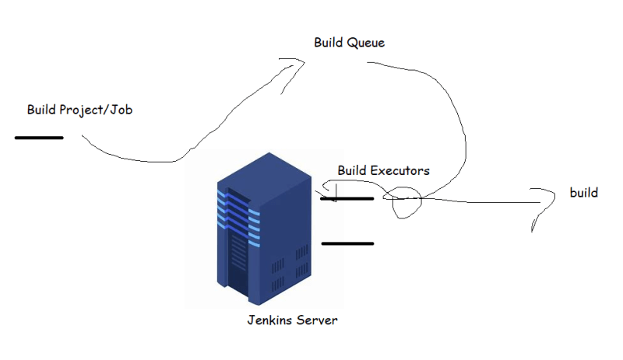

**Distributed Builds**

